**Learning Outcomes**

1. Understanding Remote DB using Parse
2. Continuing the ToDo app

**Adding more functionality**

After the login screen we need to add items to the ListView

Create a design as shown below.

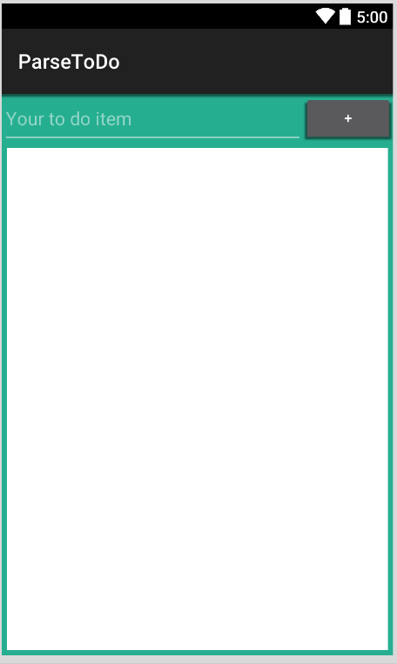

ListView

**ListActivity.axml**

**ParseHandler.cs**

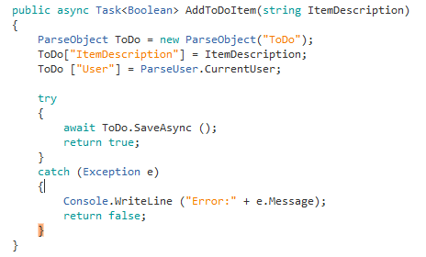

TableName

If the table does not exist Parse will automatically create one

Linking the logged in user to the ToDo table

**Viewing a list of ToDoItems**

Add a class **ToDo.cs**

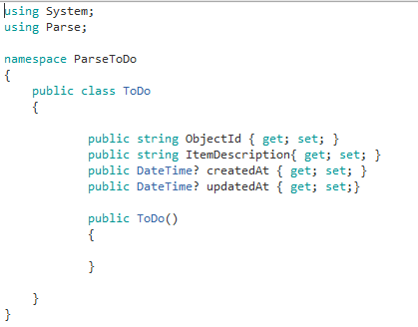

Add a New Activity, call it ViewList.cs

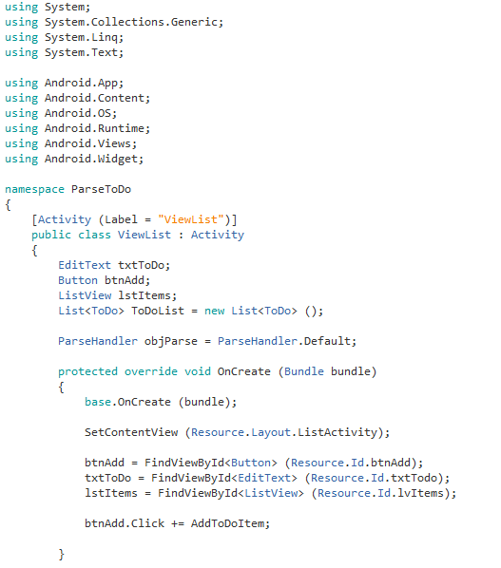

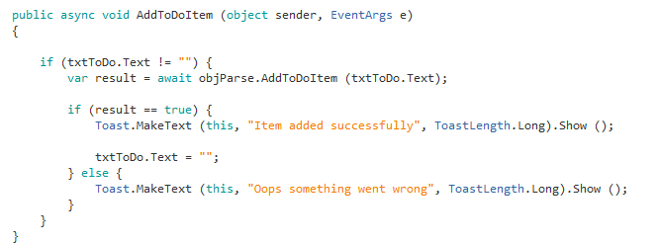

After the login click open up the ViewList Activity

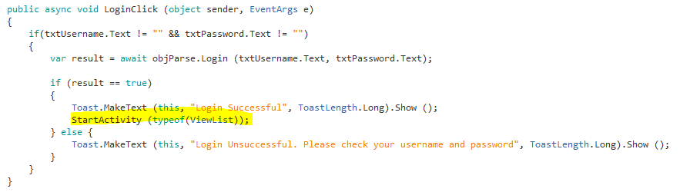

Login to your app and enter some values, check in in your Parse DB.

Clicking on the user should take you the original user.

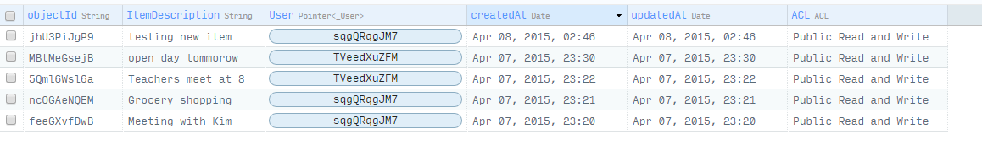

**ParseHandler.cs**

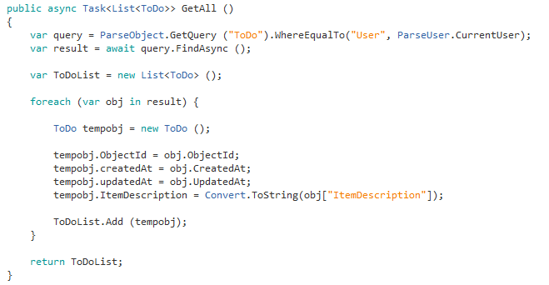

Add **customrow.axml**

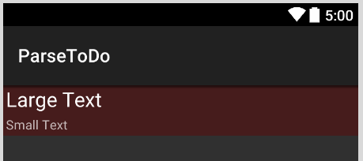

**DataAdapter.cs (Copy it from your previous projects)**

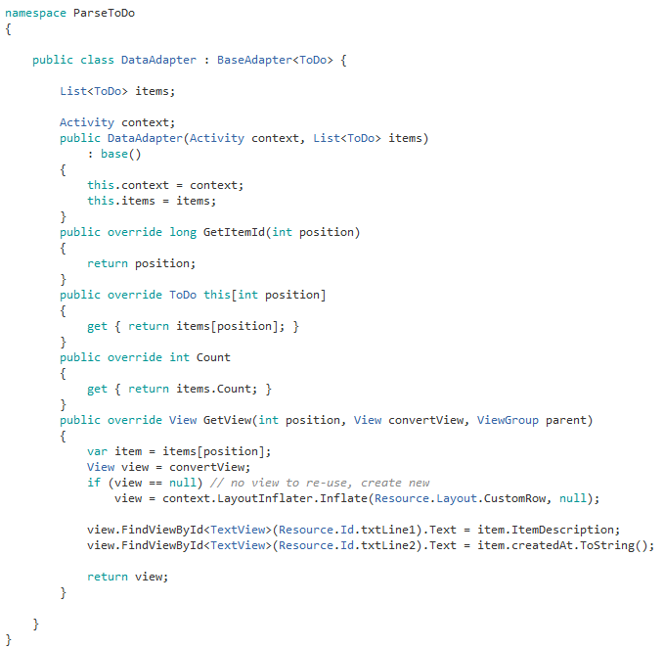

**ViewList.cs**

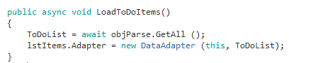

Call LoadToDoItems() in the Oncreate function and when a new item is added.

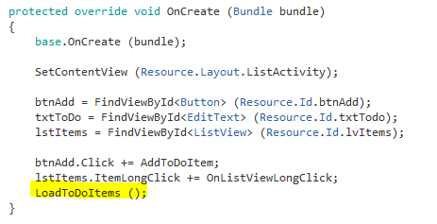

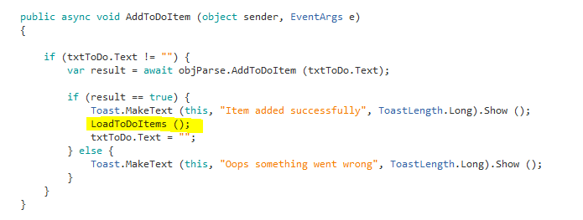

Run the app and check to see if you can view the to-do items

**Deleting To-Do Items (ParseHandler.cs)**

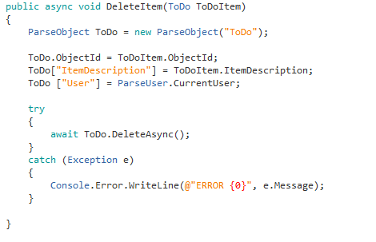

**Implementing a Long-Click delete (ViewList.cs)**

